**Summer Internship Report**

Submitted

by

**Kondamuri Lahari - AP19110010548**



**Department of Computer Science and Engineering**

**SRM University-AP, Andhra Pradesh, India**

**July - 2021**

|  |  |  |
| --- | --- | --- |
| DATA SHEET | | |
| Roll Number | : | AP19110010548 |
| Name of the student | : | Kondamuri Lahari |
| Branch & Section | : | CSE G |
| Batch | : | 2019-2023 |
| Type of internship | : | Industry internship |
| Company Name/Institute Name | : | Andhra Pradesh State Skill Development Corporation (APSSDC) |
| Company/Institute Website | : | https://www.apssdc.in/home/homepage |
| Start Date (MM/DD/YYYY) | : | 07/06/2021 |
| End Date (MM/DD/YYYY) | : | 14/07/2021 |
| Duration (No. of days) | : | 37 |
| Status of the internship | : | Completed |
| Name of internship mentor(SRM Faculty) | : | Dr.Subhrendu Chattopadhyay |
| Signature of the student | : |  |

**ACKNOWLEDGEMENT**

The internship opportunity I had with Andhra Pradesh State Skill Development Corporation (APSSDC) was a great chance for learning and professional development. Also, I consider myself as a lucky individual as I was provided with an opportunity to be a part of it. I am also grateful for having a chance to meet so many professionals who led me though this internship period.

I am using this opportunity to express my deepest gratitude and special thanks to my mentor Dr.Subhrendu Chattopadhyay ,who in spite of being extraordinarily busy with his duties, took time out to hear, guide and keep me on the correct path and allowing me to carry out my project during the training.

I express my huge thanks to Gireesha devara and Sireesha Reyyi, trainers for taking part in useful decision & giving necessary advices and guidance in project. I choose this moment to acknowledge her contribution gratefully.

I also thank my group members for their cooperation to complete the project on time.

**TABLE OF CONTENTS**

|  |  |  |
| --- | --- | --- |
| **Sl. No.** | **Content** | **Page No.** |
| 1 | Introduction | 5 |
| 2 | Objective of the Internship | 5 |
| 3 | Skills acquired through the internship | 5-6 |
| 4 | Overview of the project carried out during internship | 6-7 |
| 5 | Results | 7-9 |
| 6 | Conclusion | 10 |
| 7 | References (If any, otherwise remove this) | 10 |
|  |  |  |

1. **INTRODUCTION:**

* The internship opportunity I had with Andhra Pradesh State Skill Development Corporation (APSSDC) was a great chance for students which provides internship opportunity. Through this platform the students can acquire skills to grow their professional skills.
* I have chosen “Web Development Using Django”, It is Industrial Training Internship . The Internship was conducted between 07/06/21 to 14/07/21. The sessions are live Every day.
* In this internship we have done a group project on “ToDo List Management” website.

1. **OBJECTIVE OF THE INTERNSHIP:**

The main objective of the internship is which set by apssdc

* we have learned about important concepts of python basic and oop concept.
* To create backend web application using Django.
* We have Learned web development using Django framework.
* We have Learned about github.
* We have learned about Html, CSS websites.

1. **SKILLS ACQUIRED THROUGH THE INTERNSHIP:**

* I have acquired some skills like Python, Html, Css Git, Django frame work, Html, Css through this internship.
* This Industrial Internship helps us to build our skills and increase our professional skills.
* To Developing a website using Django framework
* The Experience of working in an internship programme
* I have improved my communication skills through this internship.

1. **OVERVIEW OF THE PROJECT/WORK CARRIED OUT DURING INTERNSHIP:**

Over the internship we learnt about Github, Installion., etc. Also concepts like accessing

Existing Repositeries, Adding to staging area, Commiting changes to repository, uses of braching, git commit, github pages., etc.

After completion about github ,our trainer started about python basics, operators, functions, loops, data structure ,tuples, lists, dictionaries, file handing, lambda, oop concept.

After python they started about Django introduction, Installation, app creation, modules in Django, creating urls, data rendering from views to templates, orm quries, crud operations .

* Our Django project is about Todo List Management.
* We have done using Html, CSS, Django frame work.
* In this project the user should sign up with his details if we doesn’t have account before.
* After sign up the user can login into the account using his details.
* The wesbsite shows to add the work to do on that day.
* If user completed the work , the website shows that in competed category.
* If user doesn’t completed work yet, then it shows in current works category.
* This project is useful for every one to complete their tasks on time.
* Our project is 3 tier architecture.

1. **RESULTS/OUTPUT**

**LOGIN PAGE**

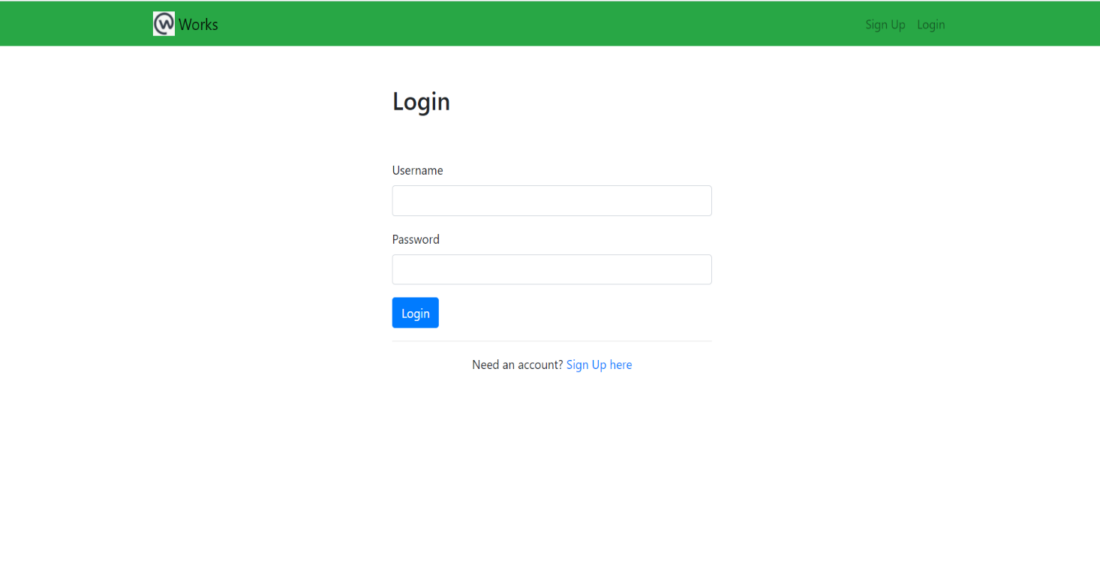

**WORK PAGE**

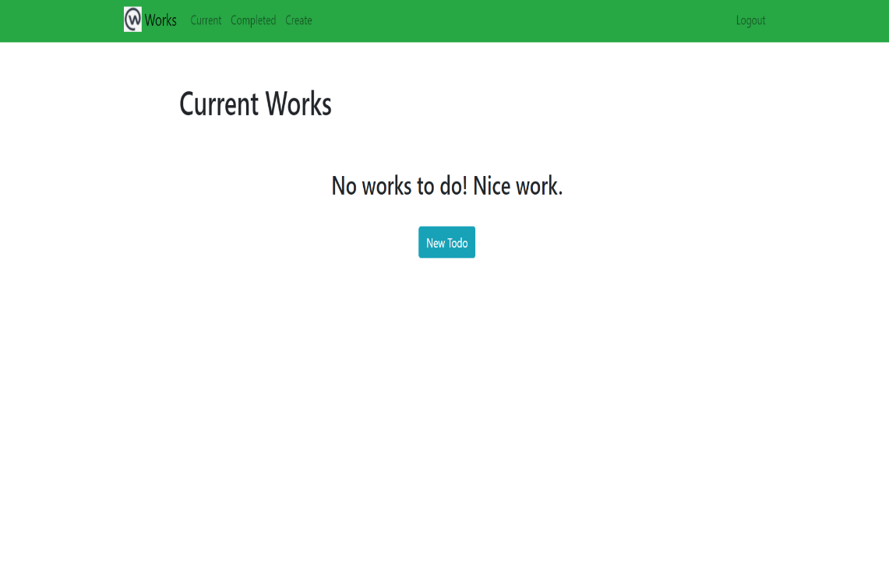

**ADD WORK PAGE:**

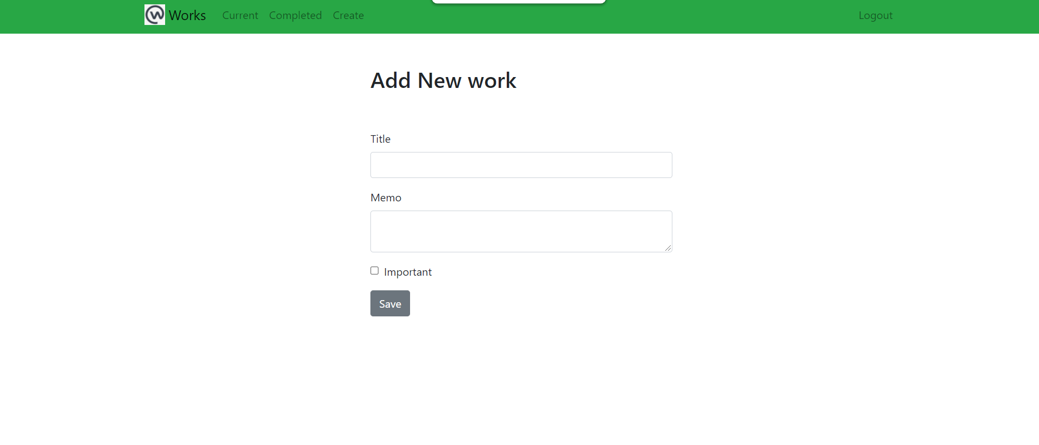

**CURRENT WORK PAGE:**

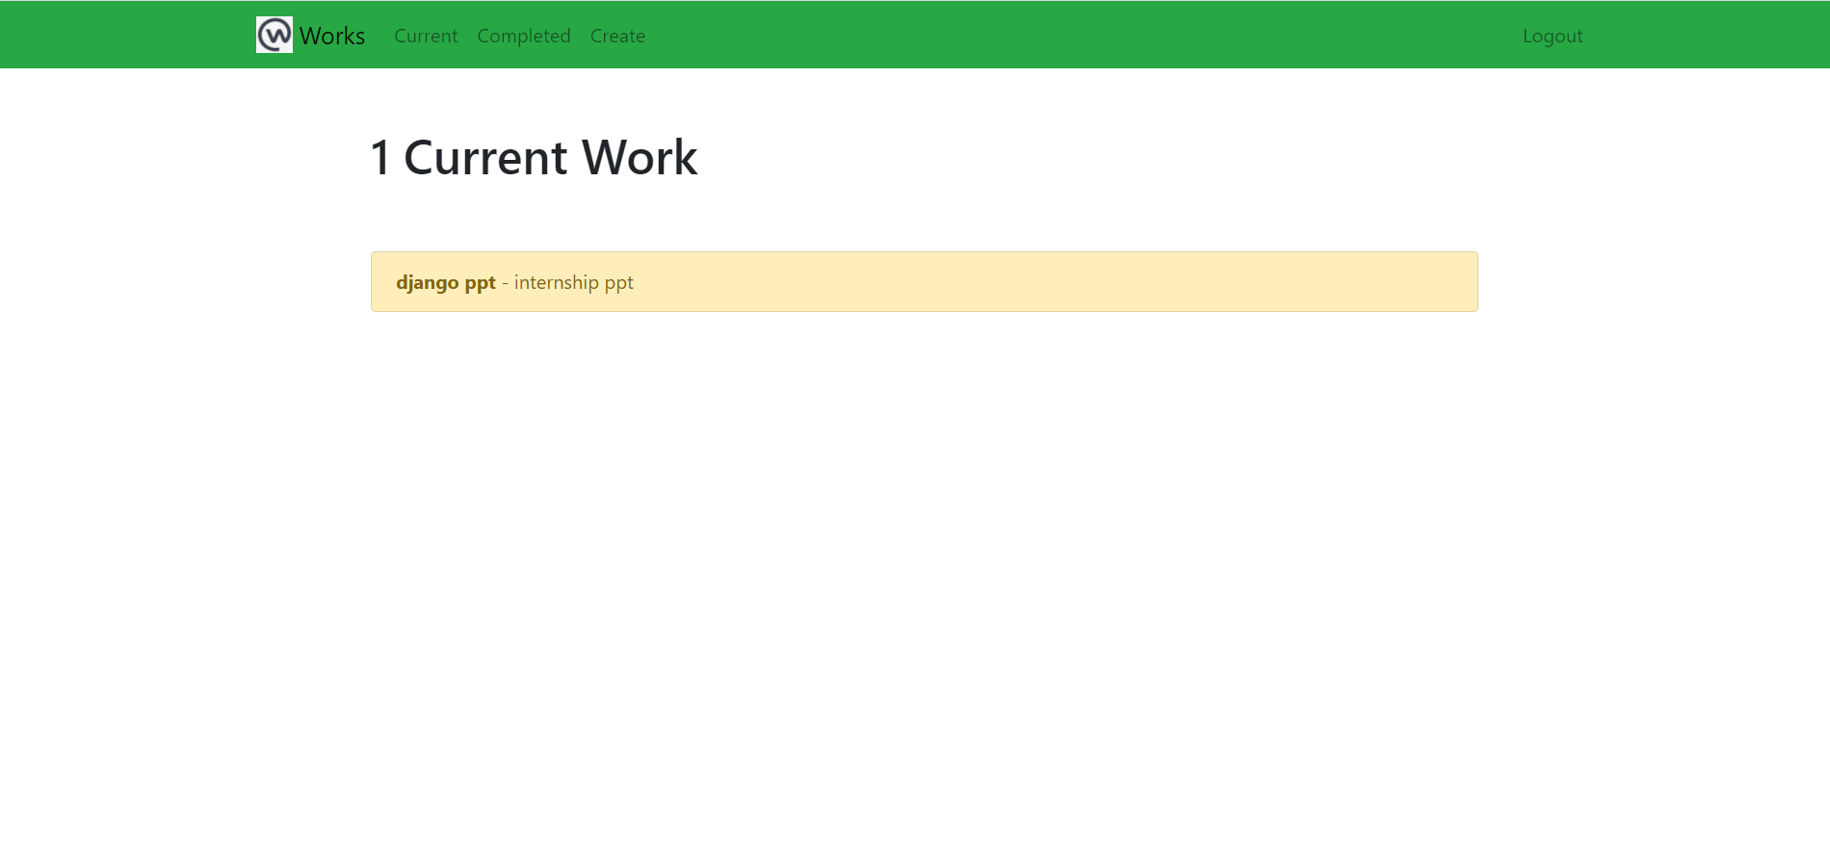

**COMPLETED WORK PAGE:**

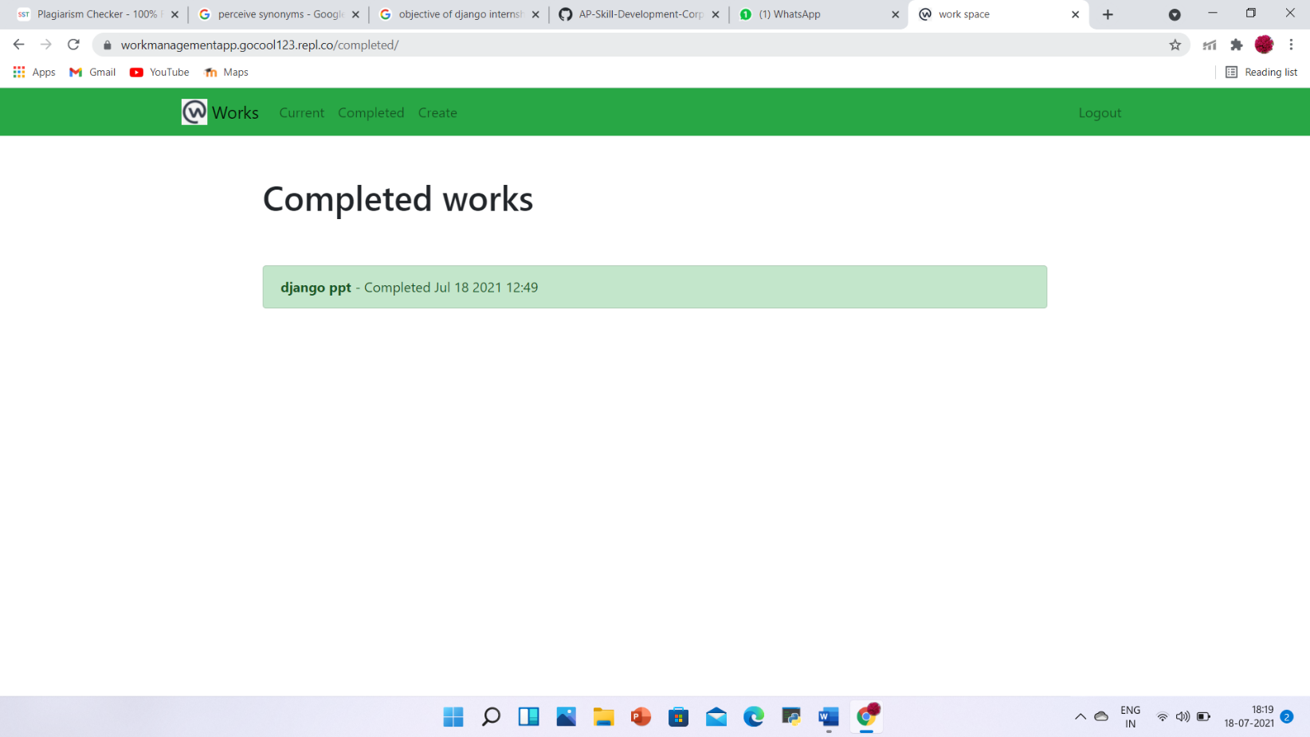

1. **CONCLUSION:**

* The internship opportunity I had with Andhra Pradesh State Skill Development Corporation (APSSDC) was a great chance to improve my skills.
* Through this internship I have learnt many things and met new members.
* My trainer is so friendly and she helped to complete our project and I also improved my communication skills.
* Through this internship I have came to know that how to be a team member and how other team members plays a key role to complete project.
* Through this internship I have gained some knowledge it leads to next step in my carrier.
* By doing this project I have gone through so many websites to increase my knowledge.

1. **REFERENCES :**

* <https://www.w3schools.com/python/>
* <https://www.atlassian.com/git/tutorials/what-is-git>
* https://developer.mozilla.org/en-US/docs/Learn/Server-side/Django/Introduction